Stability and Change in Biological Communities

A biological community consists of all the types of organisms that live in an area. In this activity, you will investigate the causes of long-term stability or change in the types of organisms in several different biological communities.

1. What do you already know about how biological communities change over decades or longer? Suggest some possible causes of long-term change or stability in the types of organisms in a biological community.

Stability in a Hawaiian Tropical Forest

2. This figure shows some of the interactions in a Hawaiian tropical forest. Use the letter of each of the descriptions below to label the relevant arrow or arrows in the figure. Each arrow should have a label.  - The fruit-bearing shrubs attract birds that eat fruits.  - The feces of these birds deposit seeds which develop into fruit-bearing shrubs.  - The trees and shrubs provide the shade and high humidity which are ideal growing conditions for the moss below them. | 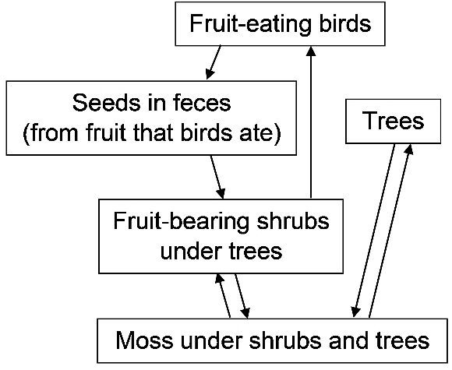
- The moss provides ideal conditions for the seeds of the trees and shrubs to sprout.
3a. Mutualism is an interaction between two species that benefits both species. Describe two examples of mutualism in this Hawaiian tropical forest.

3b. Explain how mutualism helps to maintain the stability of this Hawaiian tropical forest.

Life Comes to a New Volcanic Island
4. In the mid-1960s volcanic eruptions formed Surtsey Island, a new island with no living organisms. Within 50 years, biological communities developed on this small, barren island. How could a biological community begin on this island?

About 20 years after the formation of Surtsey, seagulls started a breeding colony on the island. These gulls ate fish from the sea and berries and grain from plants on nearby islands. Thus, the gulls’ feces contained fertilizer and seeds. 20-30 years after the gulls started breeding on Surtsey, researchers found the following differences between inside and outside the gull colony.

 | Inside the Gull Colony | Outside the Gull Colony | 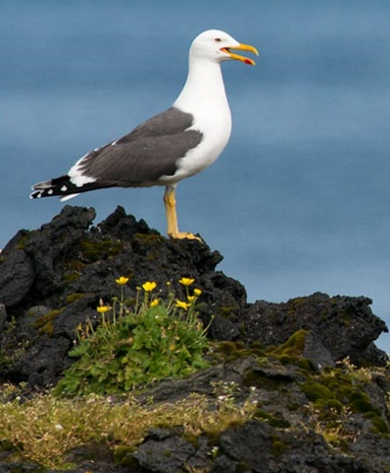
Number of gull nests per 1000 m² | 3.9 | 0.01
% of area covered with plants, mainly grass and other low flowering plants | 90% | 7%
Number of small invertebrates that researchers caught per day; many of these invertebrates feed on decaying plants and animals | 126 | 34

5a. Which area had more plants? inside the gull colony ___ outside the gull colony ___
5b. Propose an explanation for this difference.

6a. Make a claim about where there were more small invertebrates and why.

6b. What evidence supports your claim?

6c. What reasoning links your evidence to your claim?

Outside the gull colony, biological communities have begun to develop on Surtsey Island, although much more slowly than inside the gull colony. To learn more about how these biological communities are developing, complete the primary succession interactive at https://biomanbio.com/HTML5GamesandLabs/EcoGames/succession_interactive.html. Primary succession is the gradual development of a biological community in an area that began with no soil (and no seeds, plants or other organisms). Pay particular attention to lichens.

7a. How can lichens live on bare rock with no soil?

7b. Explain how lichens slowly change their environment in ways that allow mosses and other plants to grow.

Changing Biological Communities in Abandoned Farm Fields
These pictures illustrate several stages typically observed after a farm field has been abandoned to nature in the eastern US.

Years after farm field abandoned | 1-5 years | 10-15 years | >20 years
 | 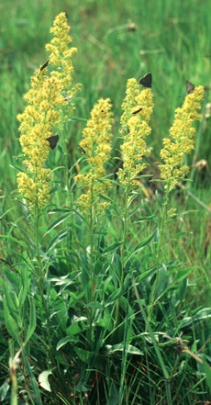 | 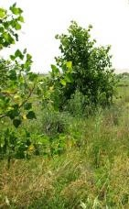 | 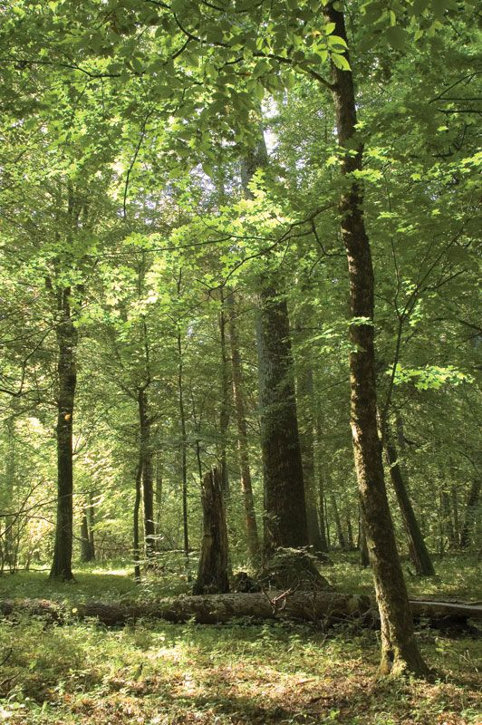
 | Grasses, wildflowers and weeds with a few shrub and tree seedlings | Grasses, wildflowers and weeds with some shrubs and young trees | Forest

8a. When do tree seedlings first appear in abandoned farm fields?
1-5 years after the field was last farmed ___ after 10-15 years ___ after >20 years ___

8b. Why does it take more than 20 years to progress to a forest?

9. Herbaceous plants have soft stems (e.g., the grasses and goldenrod shown in the first picture above). Trees and shrubs have woody stems, which allow them to grow taller. During the later stages of succession, as a forest develops, the amount of herbaceous plants decreases. What is a likely reason for the decrease in the amount of herbaceous plants?

The progression of biological communities on abandoned farm fields is an example of secondary succession = the gradual changes in a biological community that occur after a disturbance that disrupts the biological community, but leaves the soil. (For these abandoned farm fields, the disturbance included cutting down the trees in a forest and plowing the land.)

10a. What is the main difference between primary succession and secondary succession?

10b. What is the main similarity between primary succession and secondary succession?

Several long-term studies have investigated multiple abandoned farm fields repeatedly over many years. Studies of different fields in the same region have found the following results.
- The types of plants were generally similar for different fields that had been abandoned for the same length of time. (See the pictures on the previous page.)
- However, the specific plants differed. For example, different amounts of goldenrod, dandelion and grasses were observed in different fields in the first few years after a farm field was abandoned.

11. Propose possible reasons for the differences in the specific plants.

Often, secondary succession gradually restores a biological community, so it becomes similar to the community that existed before the disturbance. However, in some cases, succession does not restore the original biological community after a disturbance. For example, disturbance can allow invasive non-native plants to become established and these plants can interfere with the expected pattern of succession.

In one area in Connecticut, succession proceeded as expected for the first three decades after the end of farming, but by the end of the fourth decade an invasive non-native vine had spread over the western half of the study area (shown in the left half of the drawing). By chance, this vine had originally sprouted on the western edge of the study area. This vine hadn't yet reached the eastern half of the study area which had the type of forest expected as the result of succession (shown in the right half of the drawing).

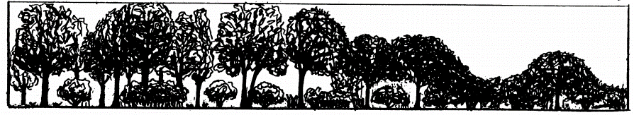
Vines growing
over trees

12a. Explain why the trees in the western half of the study area were smaller than the trees in the eastern half. (A complete answer will include photosynthesis.)

12b. In addition to invasive, non-native plants, what are some other factors that could prevent secondary succession from restoring the original biological community on an abandoned farm field?

Climate affects succession. For example, in regions with limited precipitation, succession often culminates in grasslands, rather than forests. One reason why is that trees generally need more water than grass. In addition, fires help to maintain many grasslands because fires kill tree saplings; in contrast, perennial grasses can often regenerate from their roots, which generally survive a fire.

To measure total precipitation, snow, sleet and hail were converted to the equivalent amount of rainfall per year. | This map shows major biomes in the eastern and central US. A biome is a large region with a characteristic climate and plants adapted to that climate.

13. Use the data in the above figures to explain why succession in an abandoned farm field usually progresses to:
- a forest in the eastern US, but
- a grassland in the central US.

Once succession progresses to a forest in the eastern US or a grassland in the central US, the biological community is relatively stable (unless there is a significant disturbance). This type of relatively stable biological community is sometimes called a climax community. It should be noted that change continues to occur in climax communities.

14a. Describe a type of change in a climax forest that would result in secondary succession.

14b. Describe smaller changes that occur in a climax forest that allow the forest to persist.

How does a pond become a bog?

At the end of the Ice Age, when glaciers retreated, they left behind many ponds. This figure shows that, over thousands of years, a pond and the surrounding area became a bog.
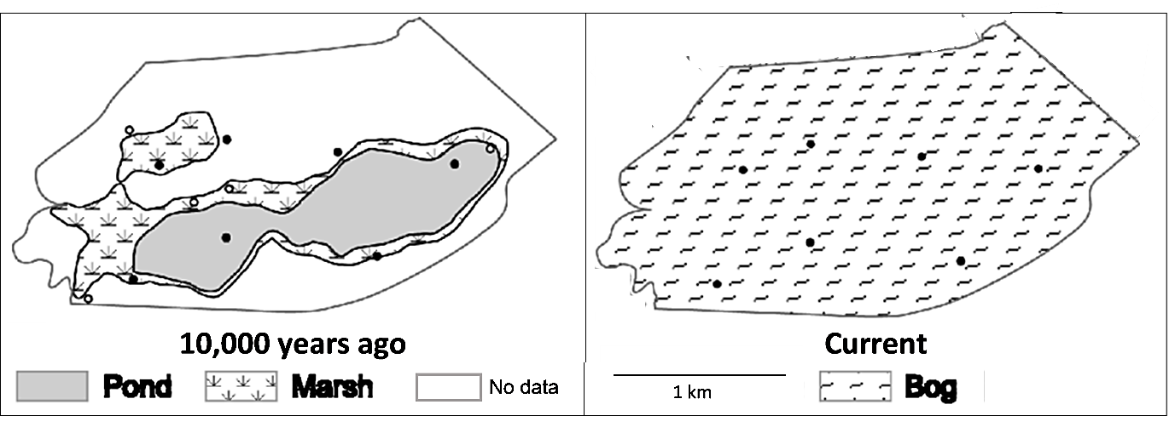

A bog is a is wetland ecosystem, as shown in this figure.
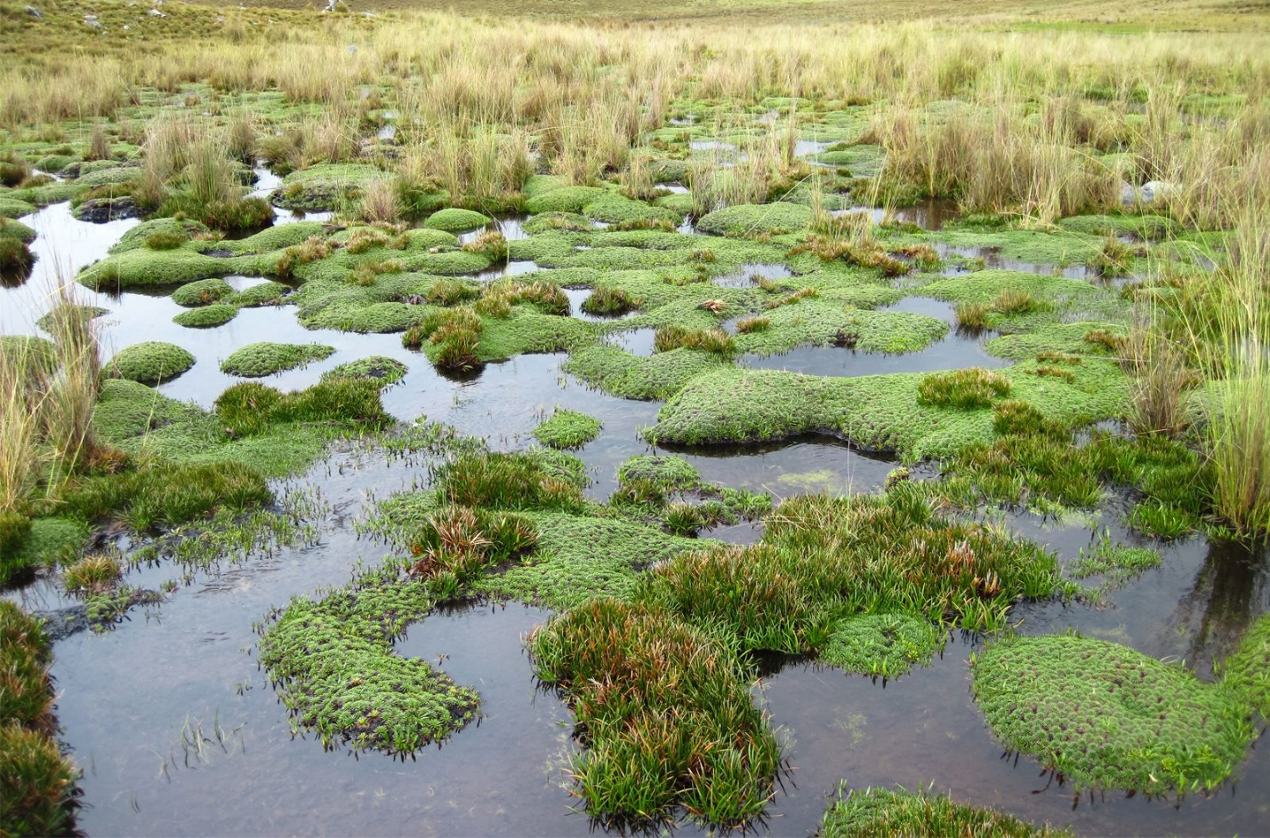

15a. Suggest a hypothesis to explain how a pond can be converted to a bog.

15b. How do you think scientists could investigate this process, which happened over thousands of years?

Fossilized remains indicate that 10,000 years ago the pond contained free-floating algae and aquatic invertebrates, plus plants that grow on the bottom of ponds. When these organisms died, they formed a layer of peat. Peat is a waterlogged spongy substance that preserves the remains of dead plants and animals.

Over thousands of years, peat accumulated, so the pond filled in and the types of plants and animals changed. Eventually, this resulted in a bog with sphagnum mosses (which make the environment acidic and waterlogged) and other plants that grow in bogs.

16a. To determine which plants and animals were present at different times in the progression from pond to bog, scientists used a device that can sample all the layers of peat under the plants in the current bog. The fossils in the different layers of peat indicate the plants, animals and other organisms that lived and died during different time periods. Which fossils would be the oldest?
a. the fossils in the bottom layer of peat
b. the fossils in the top layer of peat, right under the plants

16b. Explain your reasoning.

17. One way that succession occurs is that plants and animals in a biological community modify their environment, so a different biological community with different plants and animals gradually develops. Explain how this process occurs during the progression from pond to bog.

18a. These same processes have been observed in a study that investigated succession in a much smaller pond from 1926 to 1972. The pond gradually filled in, and bog plants grew into the pond from the outer edges. The bog plants advanced into the pond at an average rate of about 2 cm per year. If the original pond was 16 m across, about how long would it take for succession to convert this small pond to a bog?

18b. If you observed this pond for two years, would you be likely to notice that the pond was shrinking? yes ___ no ___
Conclusions
19. Several different types of evidence help scientists to understand stability and succession in biological communities. Complete this table to describe three different types of evidence.

Type of Evidence | Advantage of this Type of Evidence

20a. Two different mechanisms can cause succession. Organisms can change their environment in ways that allow other types of organisms to grow. Question 17 asked how this type of effect caused succession from a pond to a bog. Give another example that illustrates how organisms changed their environment in ways that contributed to succession.

20b. Give an example that illustrates how succession can result from the difference in growth patterns of herbaceous vs. woody plants.

21. What are some factors that contribute to differences in how succession proceeds in different places?
Factor | Example of How this Factor Contributes to Differences in Succession

22a. Give two examples that illustrate how a biological community that seems quite stable from year to year can look dramatically different when compared over multiple decades or centuries.

22b. Give an example to illustrate the general principle that “Patterns that are observed at one scale may not be observable or exist at a different scale.”

By Dr. Ingrid Waldron, Dept. Biology, Univ Pennsylvania, © 2023. This Student Handout, a slideshow, and Teacher Notes with learning goals, instructional suggestions and background information are available at https://serendipstudio.org/exchange/bioactivities/succession.

